Child’s Name: ________________________________________­­­_____________ Date: _________________

Address: ____________________________________ City: _______________ State: _______ Zip Code: __________

Parent/Guardian Name(s): _________________________________________________________________________

Parent/Guardian Cell Phone: __________________________ Additional Phone: ______________________________

Parent/Guardian Email Address: _________________________________________

Child’s Sex: *M F* Child’s Date of Birth: ___________________ Age: ______ Adopted: ⬜ Yes ⬜ No

Foster Child: ⬜ Yes ⬜ No

Emergency Contact and Phone Number: ______________________________________________________________

Would you like **appointment** reminders? **TEXT or NO reminders?**

**How Did You Hear About Us?** (whom may we thank?)

Referred by: ⬜ Family/Friend: _____________________________________ ⬜ Google ⬜ Yelp ⬜ Social Media

⬜ Health Professional: ____________________________________ ⬜ Other: ______________________________

Has your child ever received Chiropractic Care? ⬜ Yes ⬜ No If yes, when? ______________________________

Reasons for seeking care at Back to Health: ____________________________________________________________

(wellness, current symptoms/specific condition)

Current weight: __________ Height: ___________

**Chief Complaints/Symptoms:**

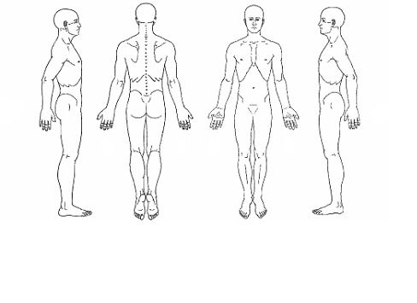

**Symptoms:** ______________________________________________________________________________________________

______________________________________________________________________________________________

______________________________________________________________________________________________

On a scale from 0-10, with 10 being the worst; **what number** best describes your symptom most of the time (mark one): 1 2 3 4 5 6 7 8 9 10 OR

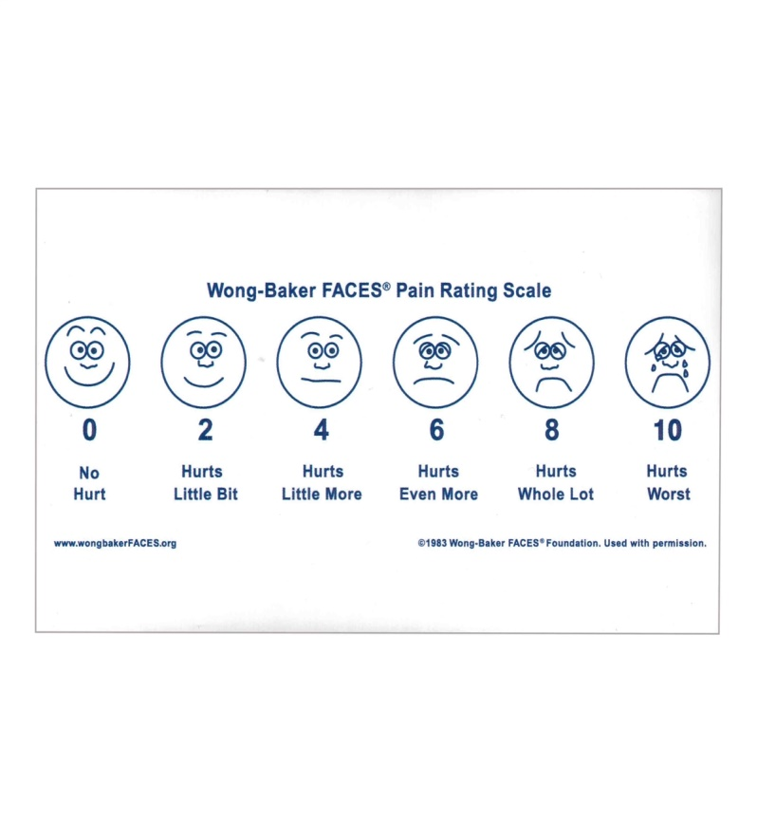

Or, if your child cannot communicate this:

⬜ child is not affected

⬜ child appears in pain/can do activities

⬜ child is in pain/limited activities

⬜ child cannot do activities/too much pain

Date of **onset**? _________________________________________________________________________________

How did these complaints develop?

_____________________________________________________________________________________________

_____________________________________________________________________________________________

Does it **radiate**? Where? __________________________________________________________________________

Additional complaints if any? _______________________________________________________________________

What causes the condition to **IMPROVE** (mark all that apply):

* rest, exercise, adjustment(s), heat, supplements(s), brace/support, stretching, walking, therapy, cold, herbal(s), medicine, over the counter medicine
* other (please describe): __________________________________________________________________

What causes the condition to **WORSEN** (mark all that apply)

* work, household duties, sports, medicine, over the counter medication, heat, stretching, brace/support, cold
* other (please describe): __________________________________________________________________

What did you try that **DID NOT** help with this condition?

* rest, exercise, adjustment (s), heat, supplements(s), brace/support, stretching, walking, therapy, cold, herbal(s), medicine, over the counter medicine
* other (please describe): __________________________________________________________________

What are you having **problems with**? (mark all that apply):

* seeing, hearing, reading, holding, walking, kneeling, lifting, sitting, sports, reclining, insomnia, loss of concentration, change in personality, tasting, bathing, typing, pinching, stooping, bending, pushing, driving, exercising, restful sleep, using the toilet, smelling, grooming, writing, standing, squatting, twisting, pulling, riding in car, loss of sexual drive, nervous, tactile feeling, eating, dressing, grasping, leaning, climbing, carrying, reaching, air travel, irritable, nothing,
* other (please describe): __________________________________________________________________

**Prior Complaints:**

Have you suffered with any of this or similar problem(s) in the past? ⬜ yes ⬜ no

• If yes, how often? ______________________________________________________________________

• When was the last episode? _______________________________________________________________

• If yes, what type of treatment? ____________________________________________________________

• Who provided the treatment? _____________________________________________________________

• How long ago? ________________________________________________________________________

• Were the results favorable or unfavorable?

**Previous Accidents:**

How long ago? ______________________________________________________________________________

Type of care received? _________________________________________________________________________

By whom? __________________________________________________________________________________

**Injuries:**

How long ago? ______________________________________________________________________________

Type of care received? _________________________________________________________________________

By whom? __________________________________________________________________________________

**Surgeries:**

How long ago? ______________________________________________________________________________

Type of care received? _________________________________________________________________________

By whom? __________________________________________________________________________________

**Birth History:**

Midwife/OB: __________________________________________________________________________________

Pediatrician/MD/APRN: _________________________________________________________________________

How many weeks at birth? ________________________________________________________________________

Birth weight/length: _____________________________________________________________________________

Congenital defects/anomalies: _____________________________________________________________________

Duration of labor/delivery: ________________________________________________________________________

Evidence of birth trauma: _________________________________________________________________________

Did they meet their milestones on time? ______________________________________________________________

Type of birth? ⬜ Natural vaginal birth ⬜ Medicated vaginal birth ⬜ Scheduled c-section ⬜ Emergency c-section

Location of birth? ⬜ At home ⬜ At hospital ⬜ At birthing center ⬜ Other: __________________________________

**Social History**

Hobby/Activity/Exercise- DESCRIBE: _______________________________________________________________

⬜ no pain ⬜ painful (can do) ⬜ painful (limits) unable to perform

**Family History**

Does anyone in your child’s family suffer with the same condition(s)? ⬜ Yes ⬜ No

⬜ grandmother ⬜ grandfather ⬜ mother ⬜ father ⬜ sister(s) ⬜ brother(s) ⬜ son(s) ⬜ daughter(s)

**Medications** (list all medications/vitamins your child is taking) ⬜ None

____________________________________________________________________________________________

____________________________________________________________________________________________

**Informed Consent**

You are the decision maker for your child’s health care. Part of our role is to provide you with information to assist you in making informed choices. This process is often referred to as “informed consent” and involves your understanding and agreement regarding the care we recommend, the benefits and risks associated with the care, alternatives, and the potential effect on your health if you choose not to receive this care for your child.

We may conduct some diagnostic or examination procedures if indicated. Any examinations or tests conducted will be carefully performed but may be uncomfortable.

Chiropractic care centrally involves what is known as a chiropractic adjustment. There may be additional supportive procedures or recommendations as well. When providing an adjustment, we use our hands or an instrument to reposition anatomical structures, such as vertebrae. Potential benefits of an adjustment include restoring normal joint motion, reducing swelling and inflammation in a joint, reducing pain in the joint, and improving neurological functioning and overall well-being.

It is important that you understand, as with all health care approaches, results are not guaranteed, and there is no promise to cure. As with all types of health care interventions, there are some risks to care, including, but not limited to: muscle spasms, aggravating and/or temporary increase in symptoms, lack of improvement of symptoms, burns and/or scarring from electrical stimulation and from hot or cold therapies, including but not limited to hot packs and ice, fractures (broken bones), disc injuries, dislocations, strains, and sprains. In addition, the literature recognizes an association between strokes and chiropractic manipulation of the cervical spine. With respect to strokes, there is a rare but serious condition known as an “arterial dissection” that typically is caused by a tear in the inner layer of the artery that may cause the development of a thrombus (clot) with the potential to lead to a stroke. The best available scientific evidence supports the understanding that chiropractic adjustment does not cause a dissection in a normal, healthy artery. Disease processes, genetic disorders, medications, and vessel abnormalities may cause an artery to be more susceptible to dissection. Strokes caused by arterial dissections have been associated with over 72 everyday activities such as sneezing, driving, and playing tennis. For comparison, the incidence of hospital admission attributed to aspirin use from major GI events of the entire (upper and lower) GI tract was 1219 events/ per one million persons/year and risk of death has been estimated as 104 per one million users.

Carotid and vertebral artery dissections are rare, with an annual incidence of 2.5 – 4 of every 100,000 people whether they are receiving health care or not. Patients who experience this condition often, but not always, present to their medical doctor or chiropractor with neck pain and headache. Unfortunately, a percentage of these patients will experience a stroke.

The reported association between visits to a chiropractor or a primary care physician and stroke is exceedingly rare and is estimated to be related in one to one million to one in two million visits.

It is also important that you understand there are treatment options available for your child’s condition other than chiropractic procedures. These options may include, but are not limited to: self-administered care, over-the-counter pain relievers, physical measures and rest, medical care with prescription drugs, physical therapy, bracing, injections, and surgery. Lastly, you have the right to a second opinion and to secure other opinions about your circumstances and health care as you see fit.

I have read, or have had read to me, the above consent. I appreciate that it is not possible to consider every possible complication to care. I have also had an opportunity to ask questions about its consent and by signing below, I agree with the current or future recommendation to receive chiropractic care as is deemed appropriate for my child’s circumstance. I intend this consent to cover the entire course of care from all providers in this office for my present condition and for any future condition(s) for which I seek chiropractic care from this office.

______________________ __________________________________ _______________

Patient’s Printed Name Signature of Patient (guardian signature if patient is under 18) Date

_______________________ __________________________________ _______________

Office Staff Printed Name Signature of Office Staff Date

**Consent to Treat a Minor**

I (we) being parents, guardian or custodian of minor, __________________________, age _____, do hereby authorize, request, and direct this office, its doctors and staff to perform examinations and any chiropractic treatment that in their judgement is deemed advisable or is required while said minor child is under care of this office’s doctors and staff until legal age. All charges for service and care given to said minor child will be charged directly to me (us) and I (we) will be personally responsible for payment of them. I (we) hereby authorize the doctor to release all information necessary to secure payment of benefits. I authorize the use of the signature on all insurance submissions.

_____________________________________________ ______________

Parent, Guardian, or Custodial Signature Date

_____________________________________________ ______________

Witness Date

**Notice of Privacy Practices (HIPAA Consent Form)**

By signing below, I understand that some of my child’s health information may be used/and or disclosed by Back to Health Chiropractic and Wellness to carry out treatment, payment, or healthcare operations. For a more complete description of such uses and disclosures I should refer to Back to Health Chiropractic and Wellness’s privacy notice entitled “HIPAA Notice of Privacy Practices”. I understand that I may view this notice any time prior to signing this form.

This notice describes how health information about you may be used and disclosed and how you can get access to this information, and applies to all protected health information contained in your health records maintained by us. We have the following duties regarding the maintenance, use and disclosure of your health records:

1. We are required by law to maintain the privacy of the protected health information in your records and to provide you with this Notice of our legal duties and privacy practices with respect to that information.

2. We are required to abide by the terms of this Notice currently in effect.

3. We reserve the right to change the terms of this Notice at any time, making the new provisions effective for all health information and records that we have and continue to maintain in accordance to changes in the law. All changes in this Notice will be prominently displayed and available at our office.

**You have the right to:**

• Get a copy of your child’s medical record

• Correct your child’s medical record

• Request confidential communication

• Ask us to limit the information we share

• Get a list of those with whom we’ve shared your information with

• Get a copy of this privacy notice

• Choose someone to act for your child

• File a complaint if you believe your child’s privacy rights have been violated

**We will never share your child’s information unless you give us written permission:**

• Marketing purposes

• Sale of your information

• Most sharing of chiropractic and treatment notes

**Our responsibilities:**

• We are required by law to maintain the privacy and security of your child’s protected health information

• We will let you know if a breach occurs that may have compromised the privacy or security of your child’s information

• We must follow the duties and privacy practices described in this notice and give you a copy of it if requested

• We will not use or share your information other than that is described here unless you tell us in writing.

**Check one:**

⬜ Back to Health Chiropractic and Wellness does NOT have my permission to share my child’s information.

⬜ Back to Health Chiropractic and Wellness CAN release my applicable information to ______________________________

(name of individual)

______________________ __________________________________ _______________

Patient’s Printed Name Signature of Patient (guardian signature if patient is under 18) Date

**Financial Arrangements**

**Please check one:**

____ SELF-PAYMENT: I am responsible for services rendered to my child and will be paid in full at the time of service unless other arrangements have been made. A $25.00 fee for returned checks to cover any fees that apply from the transaction.

____ INSURANCE PAYMENT: Coinsurances, copayments, deductibles and/or non-covered services are due at each appointment. Insurance benefits are checked by the staff as a courtesy, but they are not a guarantee of benefits/payment. Coinsurance, copays and other allowable information given to us is an estimate, and further payment may be required after your claim has been paid. Ultimately it is your responsibility as the patient’s parent to know your child’s insurance coverage. Any balances remaining unpaid after 60 days may be turned over to a collection agency. A $25.00 fee for returned checks to cover any fees that apply from the transaction.

•I understand that no doctor can or should guarantee any “cure” for any course of treatment; therefore refunds for received treatment cannot be given.

•If unable to keep an appointment, as a courtesy to our staff and other patients, please give a 24-hour notice. If no attempt is made to contact Back to Health Chiropractic and Wellness before a missed appointment, we reserve the right to implement a $25.00 missed appointment charge. The patient’s parents will be responsible for payment.

•Any prepayment balance is refundable if treatment is discontinued at any time for any reason.

I fully understand the terms of this agreement and I may receive a copy of this agreement upon my request.

______________________ __________________________________ _______________

Patient’s Printed Name Signature of Patient (guardian signature if patient is under 18) Date